EvergreenDB FSS – How to Report Bugs

Thanks for using FSS EvergreenDB! This software was written by a couple of folks in their free time, and it will most certainly have issues.

Please follow the instructions below to file bugs so we can try to address any issues you have with the application.

Reporting Issues

If you encounter any issues while using EvergreenDB, please report them by sending an email to the following email address:

[evergreendb-bugs@googlegroups.com](mailto:evergreendb-bugs@googlegroups.com?subject=EvergreenDB%20Bug%20Report:%20%3cDescribe%20Issue%20Here%3e)

Please include the following information in Bug Reports:

1. Please describe the issue you are having
   1. How is the behavior you’re seeing different from what you expect?
2. Steps to reproduce this issue.
   1. If you can help us to reproduce the same issue, it will be easier to debug. Please provide as much information as possible on the steps you take to make this issue occur.
3. Please attach **screenshots** and the **application** **logs**!
   1. See next section for instructions on saving application logs.

How to Save Application Logs

It can be helpful to include logs from the application with bug reports. To see the application logs, Click:

**View -> Toggle Developer Tools**

In the developer tools window, select “**Console**” from the tabs at the top.

Right-click in the console displayed, and select “**Save As**”:

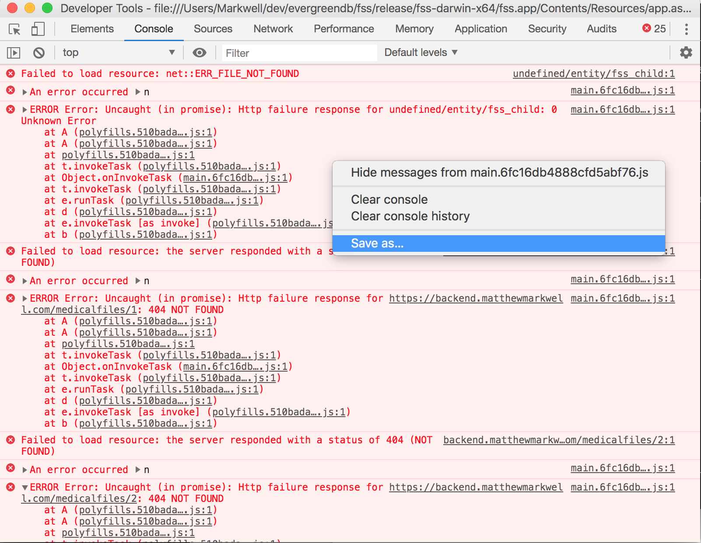

Give the file a name, and save it to some location you’ll remember.

Attach the log file to the bug report.